Autoscalling group with application load balancer
Note : - for this practical we need take a reference of Autoscaling group with simple scaling in dynamic type LAB

- Create a auto scalling group with the template if not create template please create
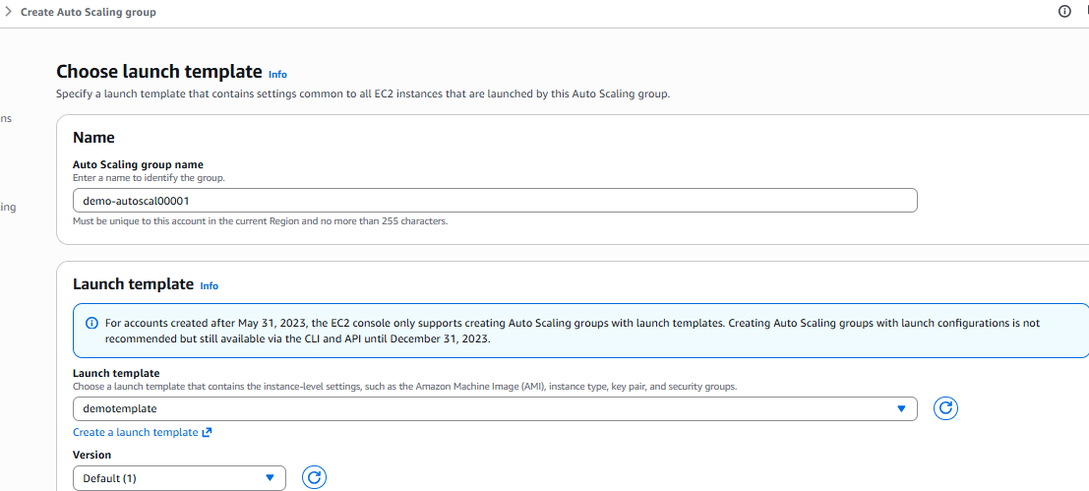
Auto scalling group has been created
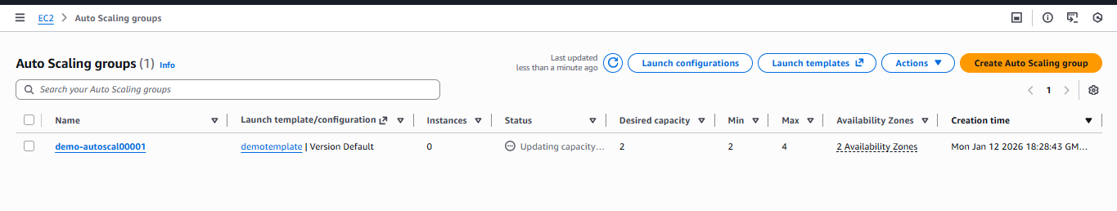
Once autoscaling group created need to add the Application load balancer from integration section in autoscaling

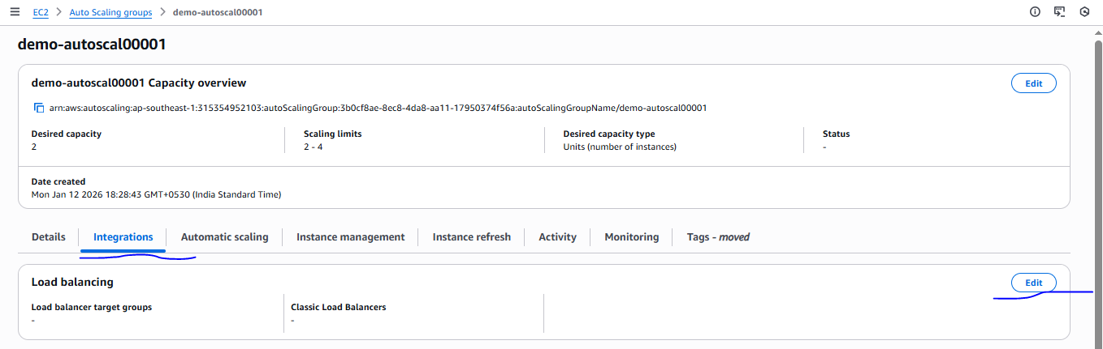
While creating application load balancer please attached the target group in target group not present please create and then attached
While creating target group don’t attached the manually instance using (include as a pending below)option in the target group otherwise autoscaling it will not work on the application load balancer
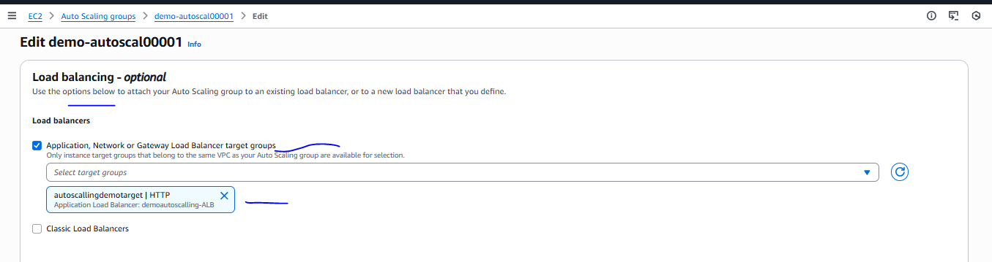

Load balancer and target group added in the autoscaling
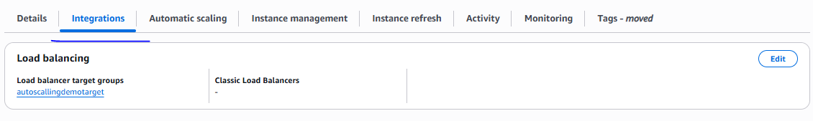
Once above step completed, please verify the application on UI using APB DNS
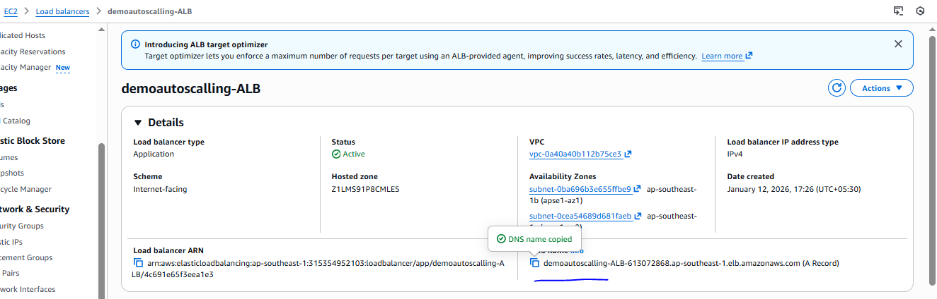

If working fine application as mention below need to add DNS in route 53 record.
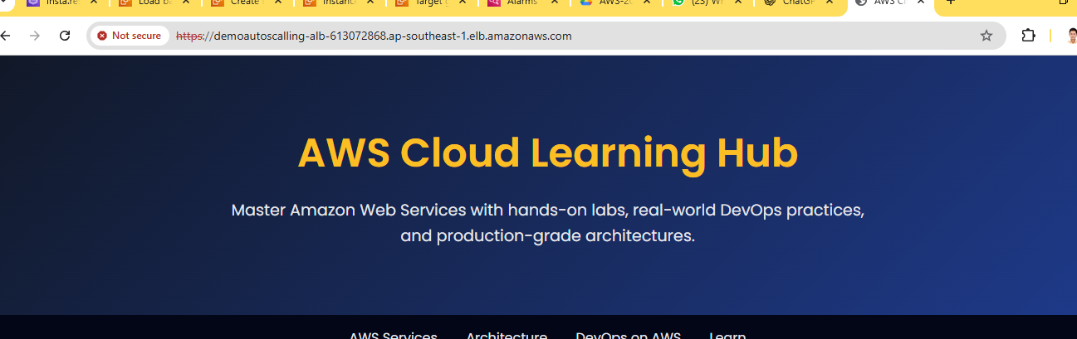
demoautoscalling-ALB-613072868.ap-southeast-1.elb.amazonaws.com
Create a record in route 53 for above DNS
Record creating
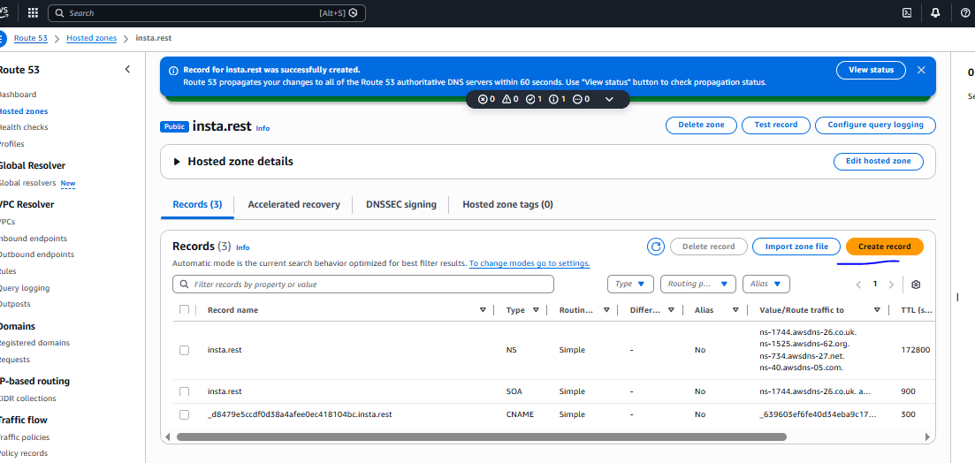

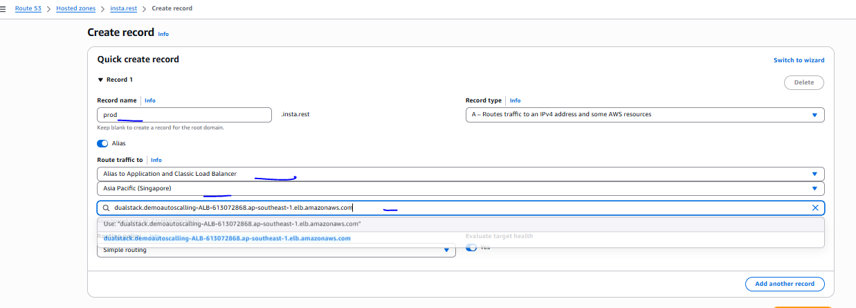

Record has been created
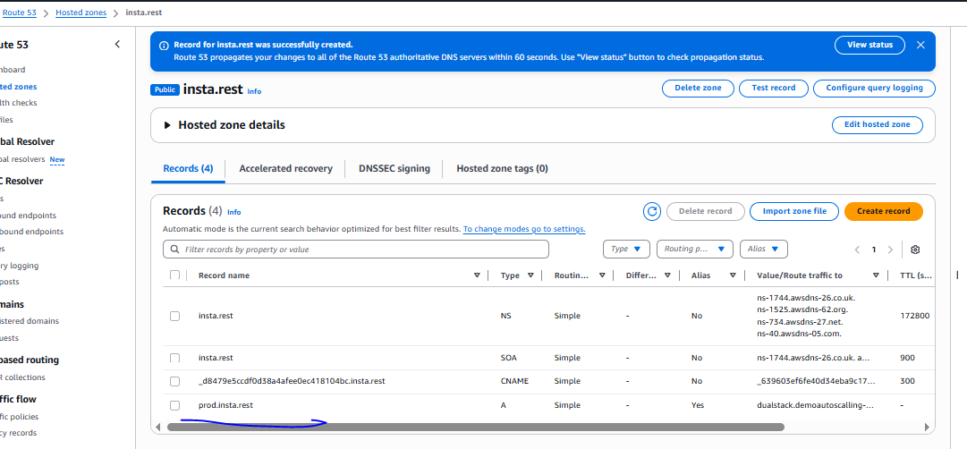
With the help of route 53 we can able to see the application page
